|  |  |  |  |  |
| --- | --- | --- | --- | --- |
|  | Finolex Academy of Management and Technology, Ratnagiri | | | |
| **Department of Information Technology** | | | |
| **Subject:** | **Networking Lab (ITL401)** | | | |
| **Class:** | **SE IT / Semester – IV (CBCGS) / Academic year: 2017-18** | | | |
| **Name of Student:** | **Kazi Jawwad A Rahim** | | | |
| **Roll No:** | **28** | | **Date of performance (DOP) :** | **02/02/2018** |
| **Experiment No:** | | **03** | **Date of checking (DOC) :** |  |
| **Title: Implementation of Specific Network topology with respect to Number of nodes and physical layer configuration.** | | | | |
| **Marks:** | |  | **Teacher’s Signature:** |  |

**1. Aim**: To Understand and implement Star and Ring topology.

**2. Prerequisites**:

Knowledge of

1. Network Topology

2. NS2 node and link commands

**3. Hardware Requirements**:

1. PC with minimum 2GB RAM

**4. Software Requirements:**

1. Linux (Ubuntu 10.04)
2. ns-2.34 package
3. Gedit

**5. Learning Objectives:**

1. To get familiar with Initialization and termination aspects of network simulator.
2. To understand defining the network nodes, links, queues and topology.
3. To understand the agents and Network Animator (NAM) and tracing.

**6. Course Objectives Applicable: LO 1, LO 2**

**7. Program Outcomes Applicable: PO2, PO4**

**8. Program Education Objectives Applicable: 1**

**9. Theory:**

**Startopology.tcl**

#***********************************************************************#

#Aim : To monitor traffic for Star topology using NS2

#***********************************************************************#

#Create a simulator object

set ns [new Simulator]

#Open the nam trace file

set nf [open out.nam w]

$ns namtrace-all $nf

#Define a 'finish' procedure

proc finish {} {

global ns nf

$ns flush-trace

#Close the trace file

close $nf

#Executenam on the trace file

exec nam out.nam &

exit0

}

#Create four nodes

set n0 [$ns node]

set n1 [$ns node]

set n2 [$ns node]

set n3 [$ns node]

set n4 [$ns node]

set n5 [$ns node]

#Change the shape of center node in a star topology

$n0 shape square

#Create links between the nodes

$ns duplex-link $n0 $n1 1Mb 10ms DropTail

$ns duplex-link $n0 $n2 1Mb 10ms DropTail

$ns duplex-link $n0 $n3 1Mb 10ms DropTail

$ns duplex-link $n0 $n4 1Mb 10ms DropTail

$ns duplex-link $n0 $n5 1Mb 10ms DropTail

#Create a TCP agent and attach it to node n0

set tcp0 [new Agent/TCP]

$tcp0 set class_ 1

$ns attach-agent $n1 $tcp0

#Create a TCP Sink agent (a traffic sink) for TCP and attach it to node n3

set sink0 [new Agent/TCPSink]

$ns attach-agent $n3 $sink0

#Connect the traffic sources with the traffic sink

$ns connect $tcp0 $sink0

# Create a CBR traffic source and attach it to tcp0

set cbr0 [new Application/Traffic/CBR]

$cbr0 set packetSize_ 500

$cbr0 set interval_ 0.01

$cbr0 attach-agent $tcp0

#Schedule events for the CBR agents

$ns at 0.5 "$cbr0 start"

$ns at 4.5 "$cbr0 stop"

#Call the finish procedure after 5 seconds of simulation time

$ns at 5.0 "finish"

#Run the simulation

$ns run

**OUTPUT:**

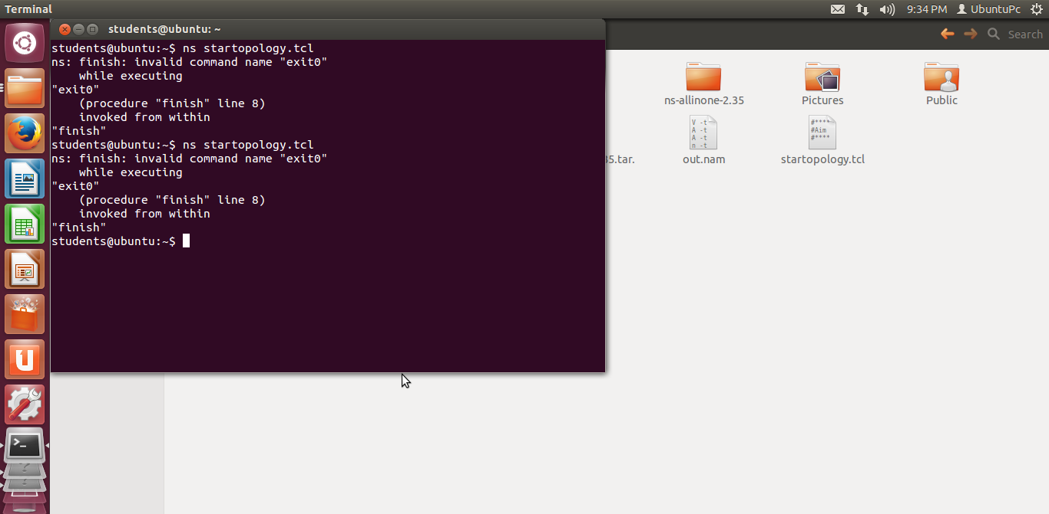

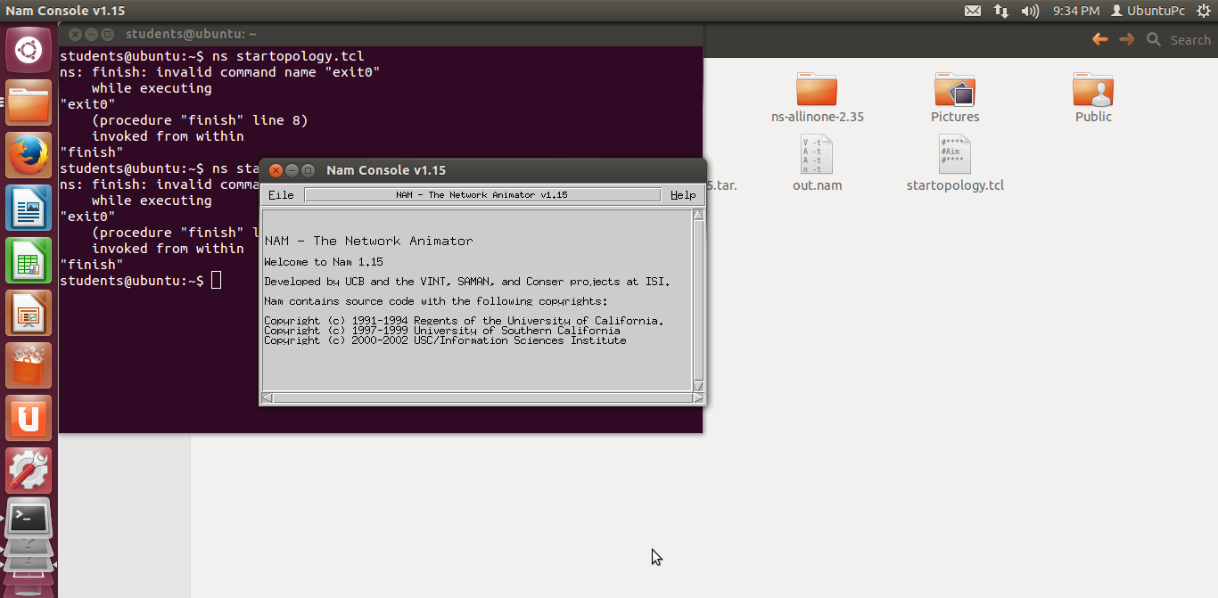

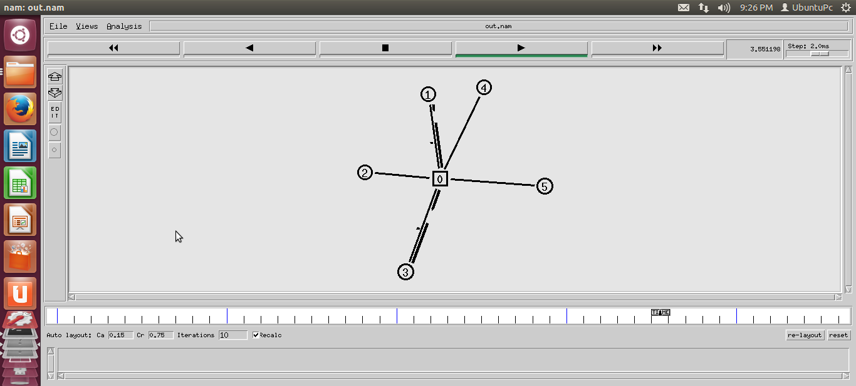

**13. Experiment/Assignment Evaluation**

|  |  |  |  |  |  |  |  |
| --- | --- | --- | --- | --- | --- | --- | --- |
| **SR** | **Parameters** | **Weight** | **Excellent** | **Good** | **Average** | **Poor** | **Not as per requirement** |
| **Scale Factor ->** | 5 | 4 | 3 | 2 | 0 |
| 1 | Technical Understanding | 25 |  |  |  |  |  |
| 2 | Performance / Execution | 25 |  |  |  |  |  |
| 3 | Question Answers | 20 |  |  |  |  |  |
| 4 | Punctuality | 20 |  |  |  |  |  |
| 5 | Presentation | 10 |  |  |  |  |  |
|  | Total out of 100 -->  #(to be converted as per term-work evaluation applicable to the subject) | | **∑ (Weight * Scale Factor)/5 = ________** | | | | |

**References**:

[1] http://www.jgyan.com/ns2/trace-file.php

[2] <http://slogix.in/how-to-create-nodes-in-ns2>

[3] http://www.jgyan.com/ns2/link%20command.php

**Viva Questions**

1. What is topology?
2. What are the types of topology?
3. What are the different types of agent?
4. Explain the format of trace file.